**RIWAYAT HIDUP**

**PERSONAL INFORMATION**

|  |  |
| --- | --- |
| **Binusian ID** | 2301944481 |
| **Full Name** | Naufaly Zuhdi Indriandi |
| **E-Mail** | [naufaly.zuhdii@gmail.com](mailto:naufaly.zuhdii@gmail.com) |
| **Address** | **Current** |
|  | Komp. Duren Villa Blok D4 No. 14 Ciledug |
|  | **Permanent** |
|  | Komp. Duren Villa Blok D4 No. 14 Ciledug |
| **Phone Numbers** | Home: -  Mobile: 081281532588 |
| **Gender** | Male |
| **Birth Place / Date** | Jakarta/ 26 December 2001 |
| **Nationality** | Indonesia |
| **Marital Status** | Single |
| **Religion** | Islam |

**FORMAL EDUCATION**

**Sept 2019 – Present** Binus Nusantara University, Jakarta, Indonesia

**Bachelor(S1), Computer Science** **GPA: 2.73**

**PERSONAL CERTIFICATION**

**October 21, 2021**

**October 14, 2021**

**October 11, 2021**

**October 12, 2021**

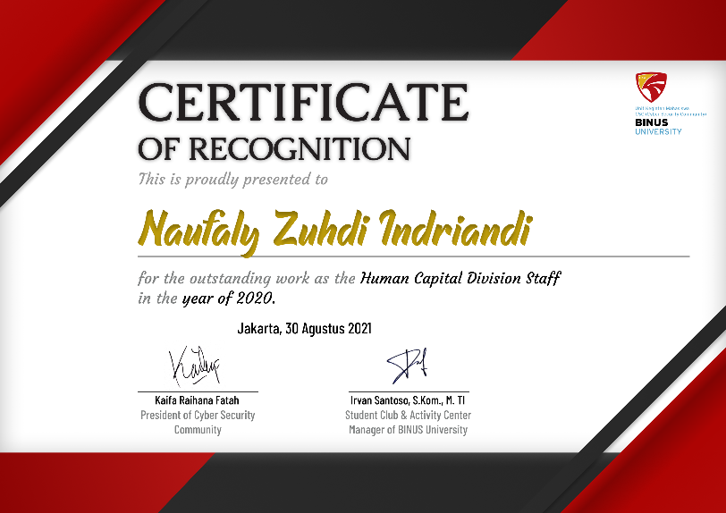

**ORGANIZATION EXPERIENCE**

**Feb 2020 – Aug 2021**

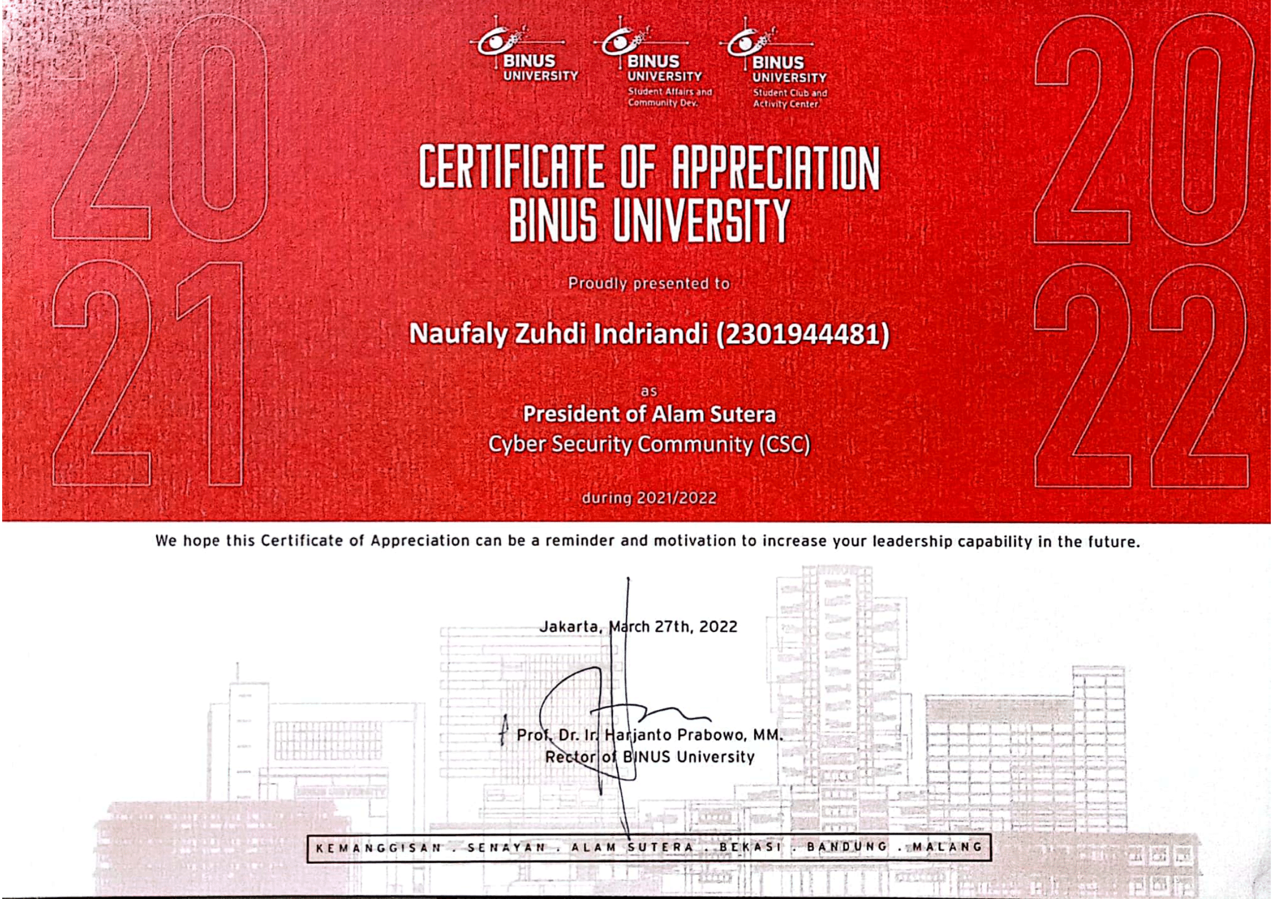

**Sept 2021 - March 202**

**Feb 2022– Feb 2023** PT Rectmedia Komputindo, Ruko Mataram Plaza B5, Jl. MT. Haryono No.427-429, Jagalan, Kec. Semarang Tengah, Kota Semarang, Jawa Tengah 50136

**WORKING EXPERIENCE**

**Job Desciption:** Programmer